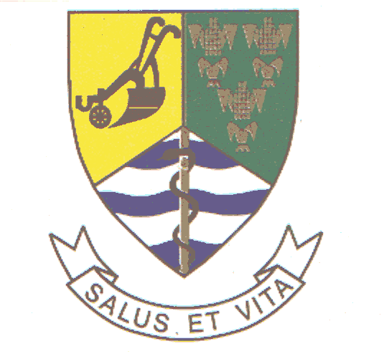

Mayoral remarks at Community Imbizo
Bela-Bela Stadium
28 October 2007

Programme Director
Speaker Maloka
Members of the Exco
Councilors
Municipal Manager
HOD’s and other Officials
Ward Committee members
Members of various political parties and CBO’s
Organized structures
Members of our community

Dumelang

Purpose:

Maikemesetso a go tla go tshwara Imbizo ke go bulela le lena ka meshomo e Masipala o e dirileng ka ngwaga wa 2006/07. Botlhokwa ke go utlwa maikutlo a lena mababi le meshomo e mengwe ya masepala.

Bjale ka ge le tseba, diterelo tsa masepala, di lebelelwa ka mo golatelago:

- Service Delivery
- Local Economic Development
- Financial viability
- Good governance
- Institutional transformation

2006/07 Programme

- Service Delivery

Project | Budget | Status
1. Radium sewer purification plant | R2.3 million | Completed
2. Upgrading of the borehole system | R1.7 million | Completed
3. Construction and upgrading of pump stations |  | Completed
4. Upgrading of electrical network in Pienaarsrivier | R150 000 | Completed
5. Installation of Street Lights in Pienaarsrivier | R150 000 | Completed
6. Renovation of old Commando offices | R110 000 | Completed
7. Construction of office blocks for municipal personnel | R80 000 | Completed
8. Upgrading of Electrical Network (township) | R300 000 | Completed
9. Fencing of pump station ext 7 | R30 000 | Completed
10. Fencing of Cemetry
11. Spatial Development Framework | R400 000 | Completed
12.1 PHP Housing Units (53) Extension 7  12.2. Out of 430 Blocked Houses, 66 have been completed.  12.3 Other Houses 73 under construction (PHP) |  | Completed

2. LED

Re kgonne go dira Spatial Development Framework. Re kgonne le go feleletsa Hawkers’ shelters tse 12.

3. Financial Viability

Mo me ngwageng ye menne/ tlhano ye fetileng, masepala ebe e na le bo thata ba Overdraft. E ra go re ne re tshomesha chelete ya go feta ye ne re kgona go e koleka. Reila re tsea matsapa go rarolla bothata bo.

Re ile radira bjalo ka go leka go beya tshomesho ye rona ya dichelete ka fase ga taolo go thibela tshomisho empe ya dichelete. Ka go le lengwe, reile ra oketsa taolo yarena ya Credit Control gore re kgone go oketsha macheleng ka go koleka go kamoka bao ba rekolotang.

Geke bolela bjale, re sana le di-case tse dilego gare go re rekgone go koleka chelete.

Re ile ra lebelela ka boswa kabo ya rena ya Free Basic Services, ye re bego re efa batho ka moka.

Mefelelong, reile ra kgona go laola Overdraft. Hona bjale ga re sana Overdraft.

Ke rata go gatelela gore re sana le batho ba bantshe, le ba dikgwebo bao ba kolokang masepala. Sekoloto seo ke +-R40m.

4. Institutional Transformation

For the first time, re kgonne go tseya magatho gore re kgone go ba le di managers in all five departments.

Ba bangwe ba bona re kgonne go ba appoint this year. We still have a challenge, ya go tiesetsa masepala le go bona gore gere recruita re thlokomela Gender Equity.

- Good Governance

Masepala o implement procurement policy ya rena.
Reile ra tiisa matsapa a rena gore go be le discipline/ maitshwaro a mabotse kamo gare ga masepala. Re sa ntse re na le challenge e kgolo gore basomi ba masepala ba shoome bja le ka team ya go botega sechabeng.

Challenge engwe e re lebane le yona ke gore re be le Anti-Fraud and Corruption Strategy.

Report for 2007/08

1. Service Delivery

Capital projects 07/08

Project | Budget | Status
Building of new municipal office | R13 million | Contractor on site
Extension of water purification plant | R5.5 million | A contractor has been appointed and work will start soon
Upgrading of electrical network in township | R300 000 | Project underway
Road paving | R1m | Project underway
Purchase of tables and chairs for Pienaarsriver | R21 000 | 150 chairs and three tables have been delivered
Testing station | R500 000 | Preparatory processes underway
Refuse bins | R70 000 | 350 purchased
Installing services in Extension 8 | R1.5 million | Project delayed due to admin reasons
Stormwater drainage | R750 00 | Preparatory processes underway
Land Use Management Scheme | R800 000 | Tender has been advertised
Housing in Radium | R14 million | 350 houses, project is underway

2. Financial Viability

As you might recall, the Bela-Bela Municipality had, over the past four years, had financial difficulties which resulted in an overdraft.

We had inherited this difficulty

Today, I am happy to announce that, as the municipality, we no longer have an overdraft. We have improved our finance significantly. But for us to be able to sustain this, we must work together.

This means our credit control policy need to be implemented vigorously, whilst on the other hand, we must tighten our control over expenditure on recruitment, overtime and other resources. We must stop and report the abuse of municipal vehicles.

Programme Director

We also want to urge our residents to also report cases where they experience water pipe burst and leakages and our streets. This is important especially because if you don’t report such, you will be charge for water losses in your yard.

The same will go to those engaged in illegally tempering and connecting electricity to their households. This is not only a dangerous activity which can result in many people being killed but it is also illegal.

We will continue engaging the local SAPS to help us in dealing with this particular problem. I can assure you that those who continue to connect electricity illegally will be prosecuted.

Programme Director

We want our residents to be vigilant and responsible by helping us in identify those culprits.

If we can do this, we will be saving not only the municipality but ourselves money that we can direct to other projects.

Housing

The provision of housing remains a priority for our municipality and to this end, we wish to report that we are in consultation with the Department of Local Government and Housing and private sector to ensure that we fast track the delivery of houses.

We have 2 500 people on the waiting list for houses, majority of them (2 200) people are for low cost houses while 300 are for middle income, according to the applications we received for middle income.

In terms of our plans for this financial year, together with Absa, we intend to built 2 315 houses that will cater for low, middle and high income households (RDP and subsidies) during our term of office.

There are several sites that have been proposed for such development and that process will be complete soon.

Programme Director, we have made inroads and wish to report that about 66 RDP houses, which were previously blocked in Pienaarsriver are complete.

We therefore call on those who have applied for RDP houses Pienaarsriver before and during 2003, to come to our offices (housing-Mabila’s office) to claim their houses.

We also have a Youth housing pilot project where about 50 RDP houses will be completed soon.

About 350 houses are to be built in Radium in the next financial year 2007/08, plus we will be servicing extra 150 stands.

Sanitation

With regard to sanitation, we have no backlog except in the developmental areas such as Rapotokwane where we have a backlog of 650 households, Ersbewoon (80) and 750 in other informal settlements in our municipality. All these areas will be attended to as we continue to work with sector departments to ensure that there is service delivery in those areas.

Water

In terms of water, all residents would know that we have managed to ensure that all of us in Bela-Bela have access to water. The only areas that need to be serviced and provided with water are Rapotokwane (325 households) and 450 at the informal settlements bring the figure to 775. (Backlog = 775)

There has been however challenges with the quality of our water. We acknowledge the problem. We however hope that the extension of the new water purification plant will ensure that we do not experience the same problems in the future.

We are also looking at our water network as part of the process to resolve the problem.

Refuse Removal

We had targeted for this financial year, to purchase 700 refuse bins for Radium and new developmental zones (extensions) in the Bela-Bela township.

We have managed to buy about 350 refuse bins. The outstanding bins will be delivered soon.

Electricity

Backlog is 1000 households, which includes Rapotokwane and Vingerkraal. Electricity in Vingerkraal will be resolved as soon as houses in Radium have been completed

LED

The council has resolved, after consultation, to relocate the community of Vingerkraal so that we can deal with all the backlogs that are there in that community.

